To: Randy Larimer
From: Jay Lamb
Regarding: Lab #1, ISE VHDL Tutorial
Date: January 26, 2009

Summary:
The first laboratory assignment involves a re-familiarization with the VHDL process. The experiment will be completed using a VHDL tutorial from Evita. The tutorial covers topics ranging from the relevance of VHDL, Objects, Processes, Architectures, etc...

Objectives:
The objective of this lab is very obvious. The VHDL language isn't extremely complicated, but it is much different than a standard programming language. A week's worth of brushing up on how to implement circuitry into FPGA's using VHDL is a good starting point for the class.

Methods:
The VHDL tutorial consists of nine unique sections, each of which covers a separate VHDL related topic.

01 – Do We Really Need VHDL?

This section describes how digital circuit design has progressed through the past years, and why the introduction of the VHDL standard is so important. The section goes on to describe the “entity”, “package”, and “architecture” structures.

02 – System Representation on VHDL : Design Units

Section 2 explains how entities can be transferred between several different architectures, why a package is efficient, and why each system must consist of both an entity and and architecture.

03 – VHDL Objects : Signal

Section 3 describes the “signal” structure in detail, outlining how they are created, directed, and assigned to ports in a system. The tutorial also describes how signals can be created to simulate single lines, or a bus of any size.

04 – Specification of a System's Interface

This section covers the syntax for entity declarations, generics, and ports. Rules for naming entities are outlined. How ports are created, and what they describe are also covered. Finally, the use of generics to describe ports is covered.

05 – VHDL Constructs For Describing System's Behavior

First, non-logical data types (boolean, character, integer, real, bit, bit_vector) are described. Logical operators (and, or, nand, nor, xor, xnor, not) also described in detail. Next, simple numerical and shift operators are demonstrated. The “after” command is presented, enabling delay to be added to a simulated circuit. Differences between constants and generics are described at the end of the section.

06 – Specifying Behavior with Processes

Creating a process is outlined in this section. Execution of a process can be controlled through the use of a sensitivity list. Next the tutorial describes how multiple variables values can be altered using a process, as well as how a value isn't modified until the process has finished execution. This section also describes how to create a logical D-filp flop using a process.

07 – Multiple Processes in an Architecture

Section 6 demonstrates how an architecture that contains multiple processes operates depending on the individual sensitivity lists of each process. Next is a visual demonstration of how a process simulates how a signal propagates through a logic circuit. A process can also be used to create both selected, or conditional statements. Finally the process behind creating a driver to initialize signals is described.

08 – Specifying the System's Structure

Section 8 begins by demonstrating how “components” can be instantiated inside of an architecture, and how these components can be connected using ports/signals.
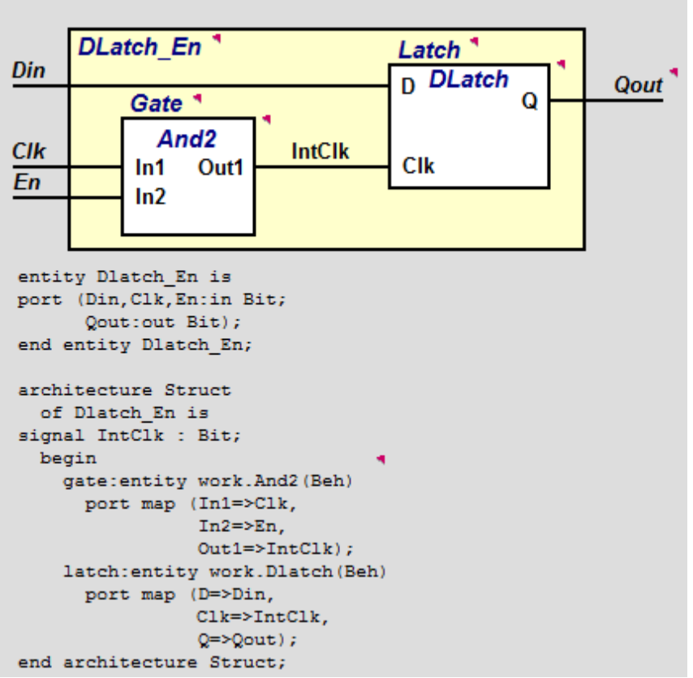
Figure 1 – Using components to create a system

09 – Testing a Design With a Test Bench

A VHDL test bench is needed to verify that the circuitry in question is actually doing what it is supposed to do. A test bench contains an entity, which has no ports. The entity must also contain an instantiation of the circuit that is being tested. Finally, a set of signals needs to be created, which will be the test inputs/outputs for the test circuit. The section wraps-up by explaining how assertion statements can be used to report progression, results, and successes or failures as values are calculated for ports in the system.

Test: N/A
Code: N/A

Attached :
1) Screenshot of completed exercise (sections 1-9)

